Week 3
C++ Environment, IDE Installation and Tool Setup
1. Objective
The objective of this practical is to install and set up a C++ programming environment on a Windows computer using Dev-C++ IDE.
The practical aims to:
- Understand the C++ development environment.
- Download and install Dev-C++ on Windows.
- Configure the IDE for C++ programming.
- Create and run a simple C++ program.
2. Software/Requirements
- Operating System: Windows
- IDE: Dev-C++
- C++ Compiler: MinGW/GCC compiler included with Dev-C++
3. Downloading Dev-C++ on Windows
Step 1: Open the Dev-C++ Download Page
Open a web browser and visit the official/source download page for Dev-C++.
Screenshot 1: Dev-C++ download page
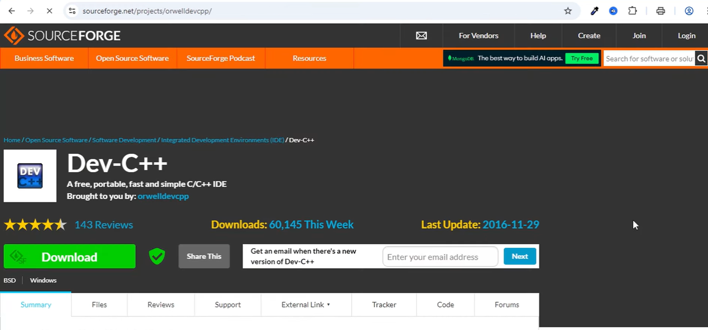

Step 2: Download the Dev-C++ Installer
Select the appropriate Dev-C++ installer for Windows and start the download.
Screenshot 2: Downloading Dev-C++ installer
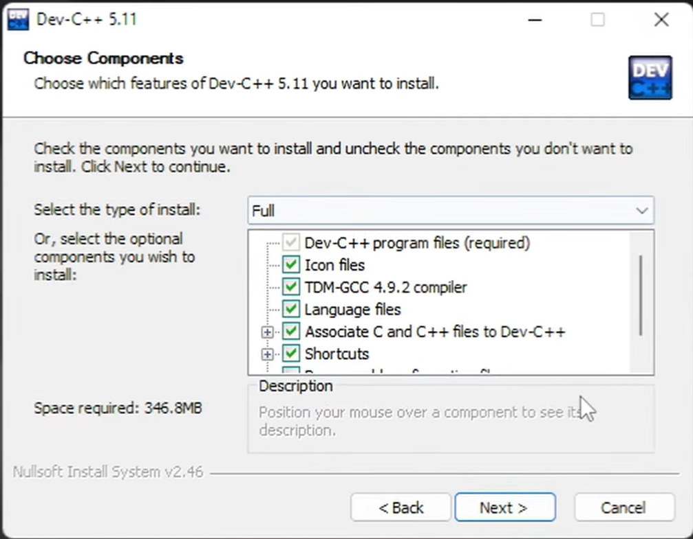
Step 3: Install Dev-C++
After downloading the installer, open the downloaded setup file. Follow the installation instructions displayed on the screen and complete the installation.
Screenshot 3: Dev-C++ installation/setup

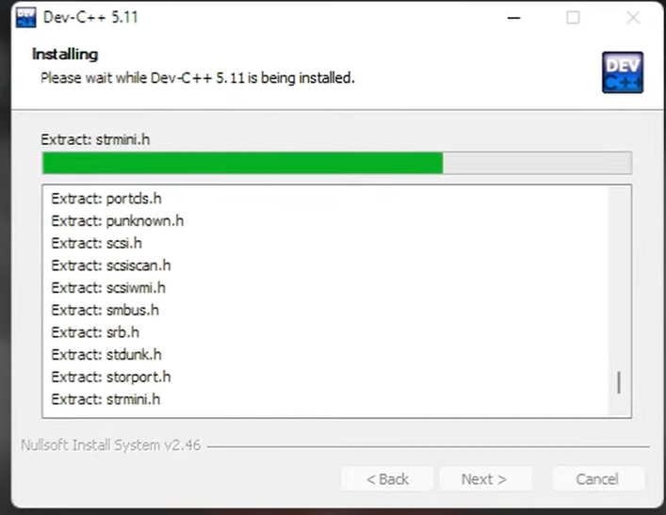
Step 4: Launch Dev-C++ and Creating a C++ Program
After successful installation, open Dev-C++ from the Windows Start Menu or desktop shortcut.
The Dev-C++ IDE provides an environment for writing, compiling, debugging, and executing C++ programs.
Screenshot 4: Dev-C++ IDE after installation
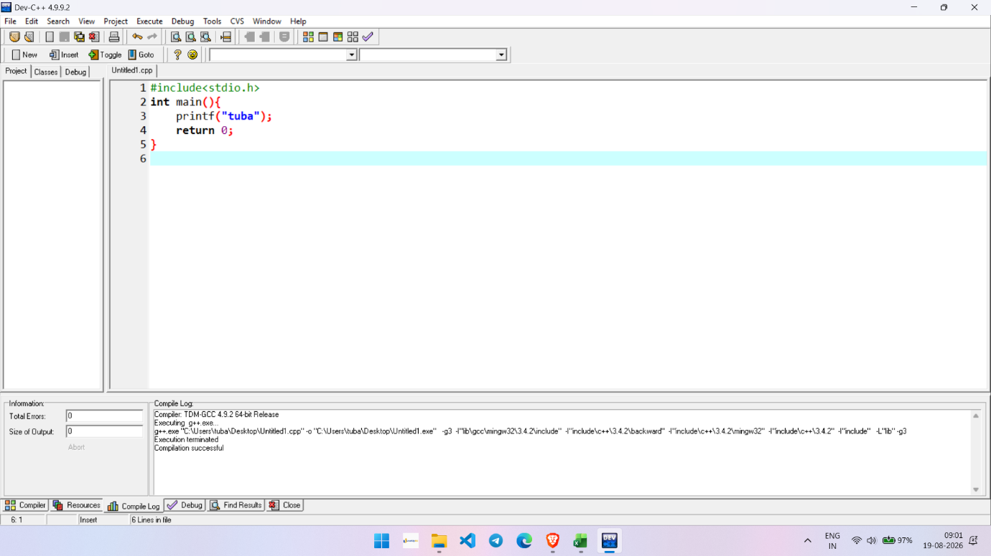
5. Compiling and Running the Program
Compile the program using the Compile option in Dev-C++.
After successful compilation, run the program using the Run option.
The output should be displayed in the console window.
6. Result
Dev-C++ was successfully downloaded and installed on the Windows operating system. The C++ development environment was set up successfully, and a simple C++ program was created, compiled, and executed.
7. Conclusion
The practical provided an introduction to the C++ development environment and the installation of Dev-C++ on Windows. The basic process of creating, compiling, and running a C++ program using the Dev-C++ IDE was also understood.

